Web Technologies Lab – 07
Table of Contents
Web Technologies Lab – 07 1
Aim: 1
Source Code 1
File 1: ./components/Counter.jsx 1
File 2: ./components/CounterButtons.jsx 2
File 3: App.css 2
File 4: App.jsx 3
File 5: Main.jsx 4
Output: 4
Conclusion: 5

Aim:
To implement a react counter app.

Source Code

File 1: ./components/Counter.jsx

import { useState } from "react";
import CounterButtons from "./CounterButtons";

function Counter() {
const [counter, setCounter] = useState(0);

const handleIncrement = () => {
setCounter(counter + 1);
};

const handleDecrement = () => {
setCounter(counter - 1);
};

return (
<div className="counter">
<div className="counter-value">
{counter}
</div>

<CounterButtons
onIncrement={handleIncrement}
onDecrement={handleDecrement}
/>
</div>
);
}

export default Counter;

File 2: ./components/CounterButtons.jsx

function CounterButtons({ onIncrement, onDecrement }) {
return (
<div className="buttons">
<button
className="increment-button"
onClick={onIncrement}
>
Increment
</button>

<button
className="decrement-button"
onClick={onDecrement}
>
Decrement
</button>
</div>
);
}

export default CounterButtons;

File 3: App.css

.app {
display: flex;
flex-direction: column;
align-items: center;
justify-content: center;
min-height: 100vh;
font-size: 300%;
}

.counter {
display: flex;
flex-direction: column;
align-items: center;
}

.counter-value {
font-size: 120%;
margin-top: 30px;
}

.buttons {
margin-top: 50px;
}

button {
font-size: 60%;
padding: 10px 20px;
border: none;
border-radius: 8px;
color: white;
cursor: pointer;
}

.increment-button {
background-color: green;
margin-right: 5px;
}

.decrement-button {
background-color: red;
margin-left: 5px;
}

button:hover {
opacity: 0.8;
}

File 4: App.jsx

import Counter from "./components/Counter";
import "./App.css";

function App() {
return (
<div className="app">
<h1>Counter App</h1>
<Counter />
</div>
);
}

export default App;

File 5: Main.jsx

import { StrictMode } from "react";
import { createRoot } from "react-dom/client";
import App from "./App.jsx";

createRoot(document.getElementById("root")).render(
<StrictMode>
<App />
</StrictMode>
);

Output:
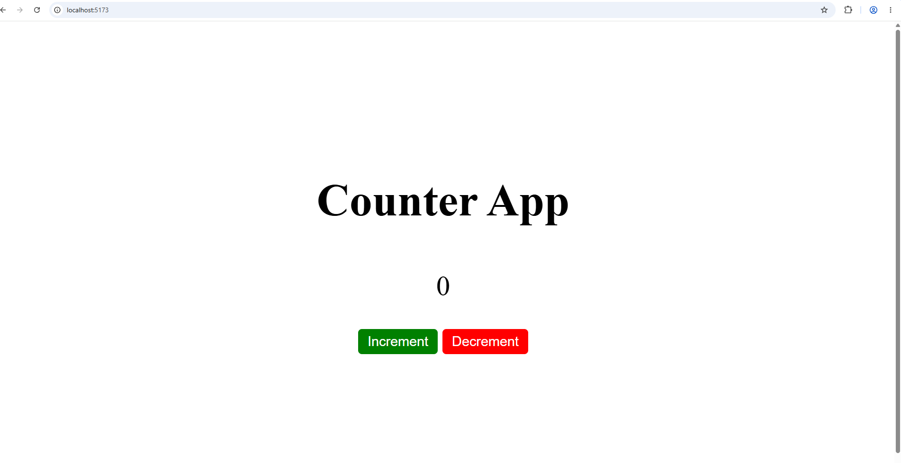

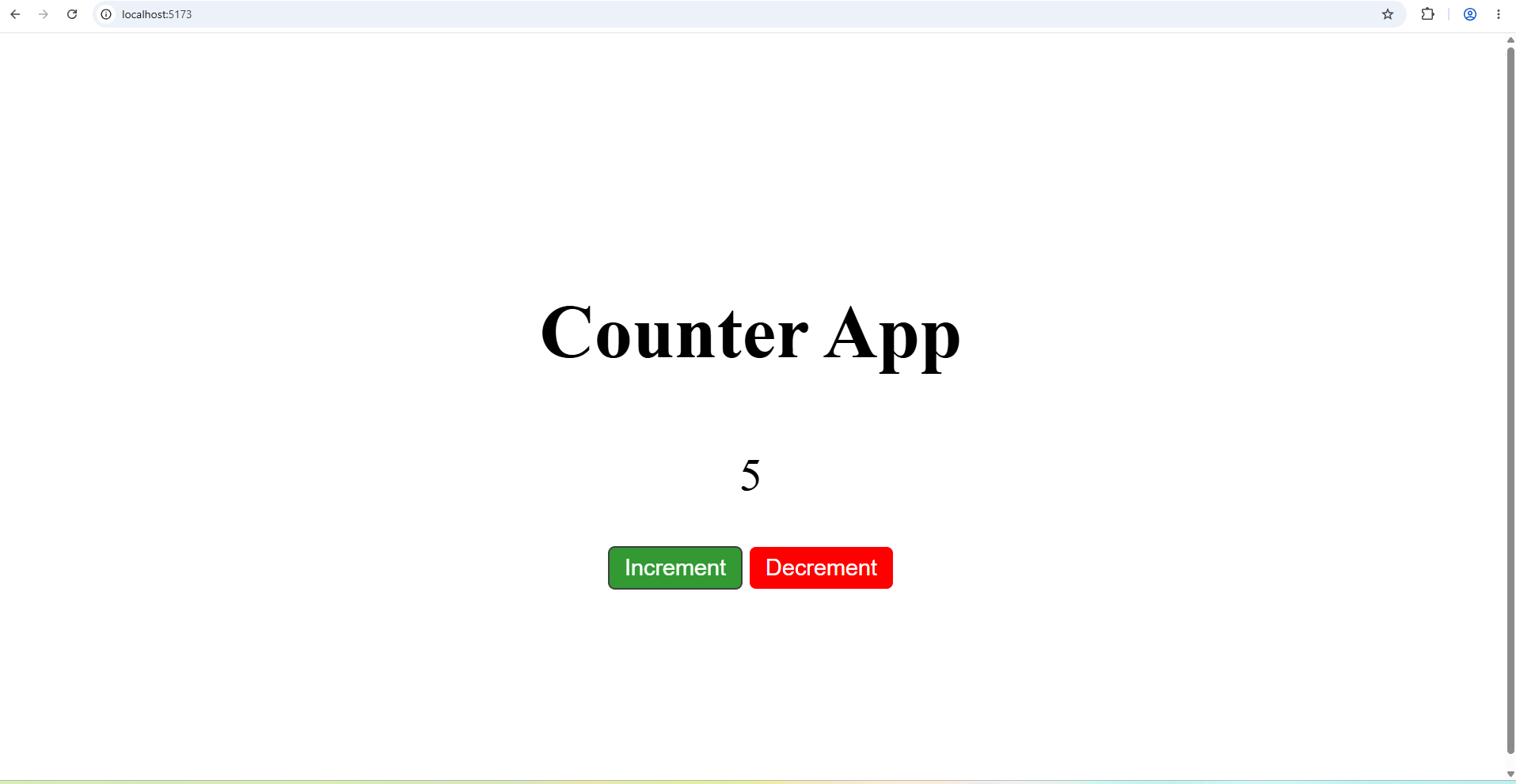

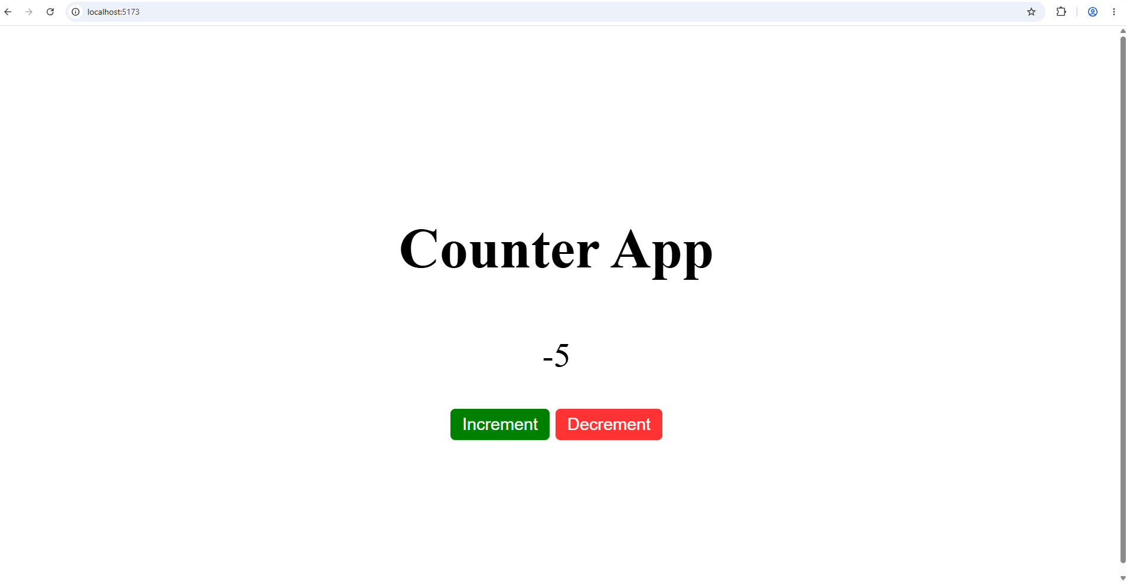

Conclusion:
We have successfully implemented a react counter app.

